Part I : MCQ
1. _________ describes the position of the waveform to time 0
a) Time
b) Frequency
c) Phase
d) Amplitude

2. In TCP/IP the _______ layer is equivalent to the combined session, presentation, and application layers of the OSI model.

  - Application
  - Network
  - Data link
  - Physical
3. In a _________ communication, the media is dedicated.

- multipoint
- point-to-point
- mesh
- None of the above

4. A packet at data link layer is normally called a_________________
a). frame
b). message
c). datagram
d). cell

5. Which of the following is an advantage to using fiber optics data transmission?
a) Resistance to data theft
b) Fast data transmission rate
c) Low noise level
d) All of above

6. Which of the following is not one of the components of a data communication system?
- message
- sender
- medium
- None of the above

- The data link layer packet in the TCP/IP protocol suite is called
  - A message
  - A Frame
  - A segment or user datagram
  - A datagram
8 Twisted in a twisted-pair help reduce the ……….
- Length
- Cost
- Noise
- None of the choices are correct

9 RJ-45 is a type of connectors used in ____________cabling.
a) twisted-pair
b) coaxial
c) fiber-optic
d) None of the choices are correct

10. Which protocol is used to resolve IP to MAC addresses?
  - DNS
  - DHCP
  - ARP
  - WEP

11. In the ________ random- access method collision is avoided.
a) CSMA/CD
b) ALOHA
c) CSMA/CA
d) None of the choices are correct.

      - 10 Gigabit Ethernet operates only in
- Simplex mode
- Half duplex mode
- Full duplex
- none

      - In 10Base5 implementation the medium length
a) 500m
b) 185m
c) 100m
d) none

      - Which of the following is an example of a controlled access protocol.
a) CDMA
b) TDMA
c) Token passing
d) none

15. A sine wave in the ______ domain can be represented by one single spike in the _____ domain.
- time; phase
- frequency; time
- time; frequency
- phase; time

PART II Fill in the Blanks
- __________means that a protocol at a layer can encapsulate a packet from several next-higher layer protocols (one at a time). (Multiplexing)

- The data sent in the network layer in TCP/IP model is called ____________ Datagram (Packet)

- In CDMA,we use different……………………… to achieve channelization.. (codes)

- ____________data have discrete states and take discrete values. (Digital)

- In fiber optics, the signal is………..waves. (light)

- In the TCP/IP protocol suite, the ________layer is responsible for moving frames from one hop (node) to the next. (data link)

- _________means that the signal changes its form or shape. (Distortion)

Part III TRUE and FALSE:

1 | Attenuation means a loss of energy | True
2 | A simple periodic analog signal, a sine wave, can be decomposed into simpler signals. | False
3 | Currently IEEE is responsible for the management of Internet Domain Names & Addresses | False
4 | A sine wave is comprehensively defined by its amplitude, frequency, and phase | True
5 | A multipoint connection is one in which more than two specific devices share a single link | True
6 | Reservation is a control access protocol. | True
7 | In the CSMA/CA random access method collision is avoided. | True
8 | In FDMA, we use different time slots to achieve channelization. | False

PART IV Short Questions.

    - Is there any relationship between transmission media and topology? Describe the transmission media and its class with diagram.

Answer:

Yes, medium should be selected based on the topology. For example, for bus topology coaxial cable medium is suitable, and for ring/star topology twisted-pair or optical fiber can be used.
Transmission medium is the means through which we send our data from one place to another.
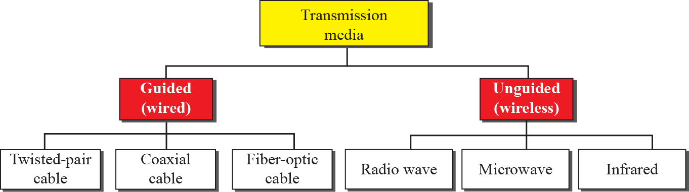

    - Discuss about the data-link layer and describe framing also.

Answer
The Data Link Layer is the second layer in the OSI model, above the Physical Layer, which ensures that the error free data is transferred between the adjacent nodes in the network. It breaks the datagrams passed down by above layers and convert them into frames ready for transfer. This is called Framing. Since the physical layer merely accepts and transmits a stream of bits without any regard to meaning or structure, it is up to the data link layer to create and recognize frame boundaries.

3. Differentiate radio waves and micro waves?
Answer:
Electromagnetic waves ranging in frequencies between 3 kHz
and 1 GHz are normally called radio waves

Electromagnetic waves having frequencies between 1 and 300GHz are
called microwaves.

4. Consider a noiseless channel being used to transmit digital data with 8 signal levels. Assume a bandwidth of 3100 Hz. Calculate the maximum bit rate using the appropriate formula?

Answer:

Using the Nyquist bit rate formula
BitRate = 2 bandwidth X log2 L
= 6200 X log2 8 = 18,600 bps

5. What is the purpose of cladding in an optical fiber?

Answer:

The inner core of an optical fiber is surrounded by cladding. The core is denser than the cladding, so a light beam traveling through the core is reflected at the boundary between the core and the cladding if the incident angle is more than the critical angle.

